**Collection Framework Assignment**

Q1. Write a class Person having weight, height & name. Create multiple person objects & print them in the sorted order. In the sorting order first sort based upon their weight & it two persons have same weight them sort them based upon their height. Use TreeSet.

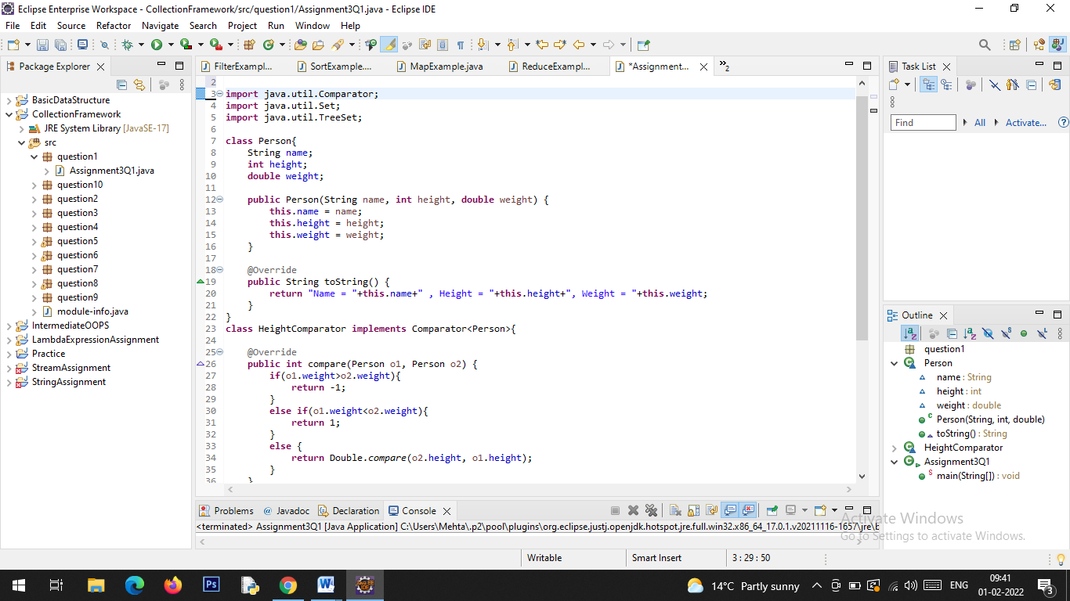

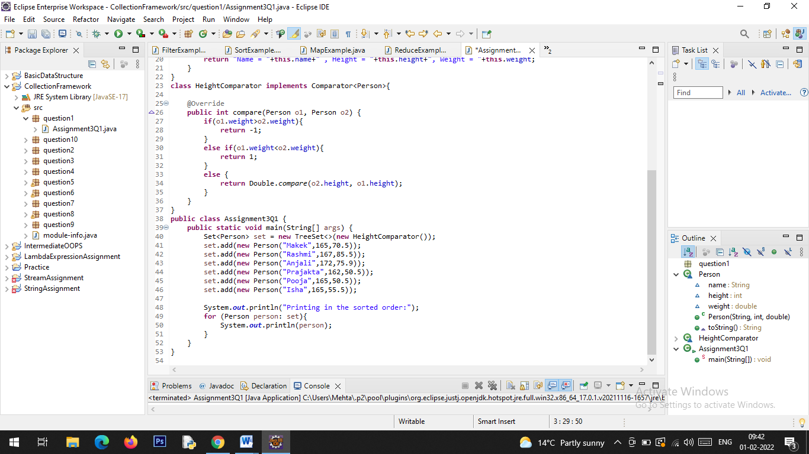

**Output:**

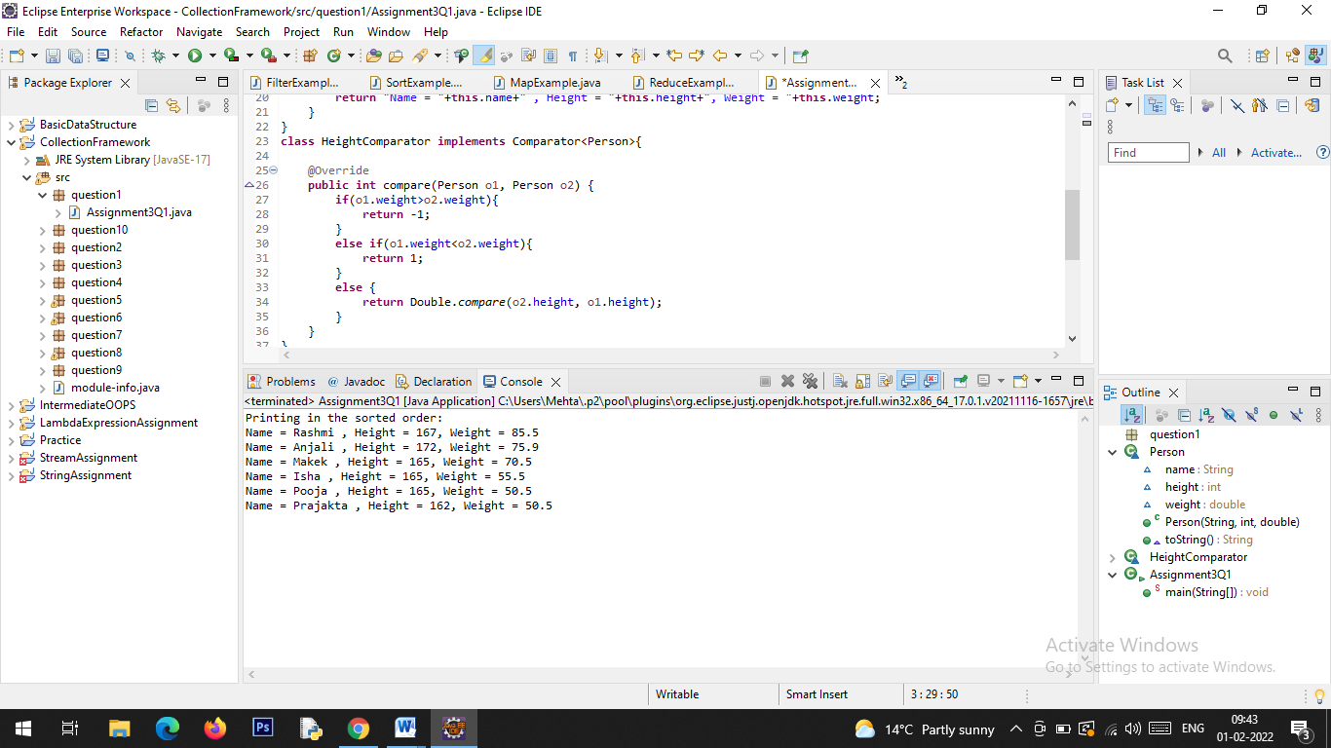

Q2. Prove that Hash Set is unordered & Linked Hash Set is ordered.

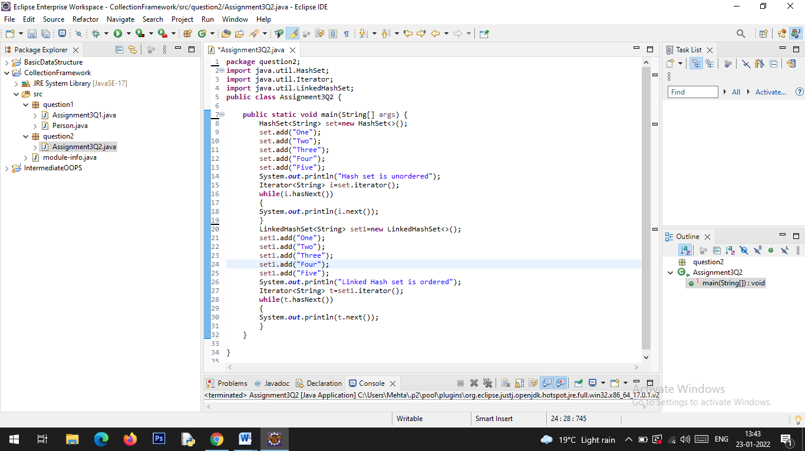

**Output:**

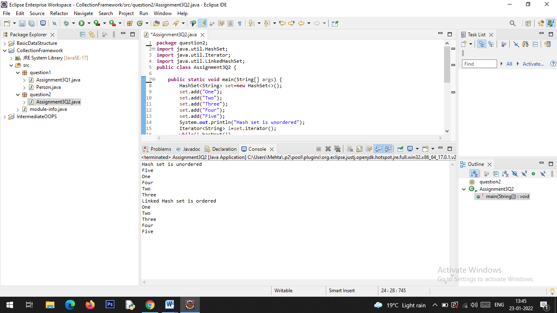

Q3. Create a ArrayList with few elements & print it in backward direction. Use ListIterator.

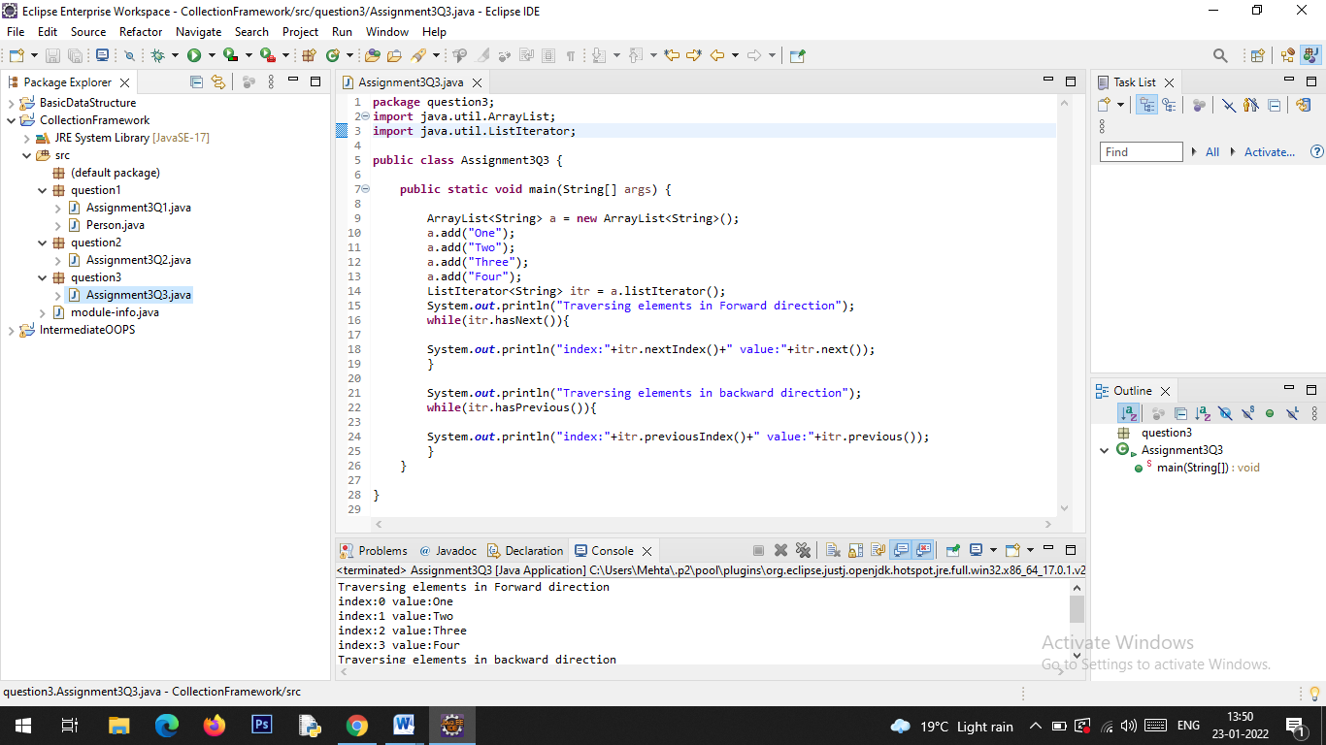

**Output:**

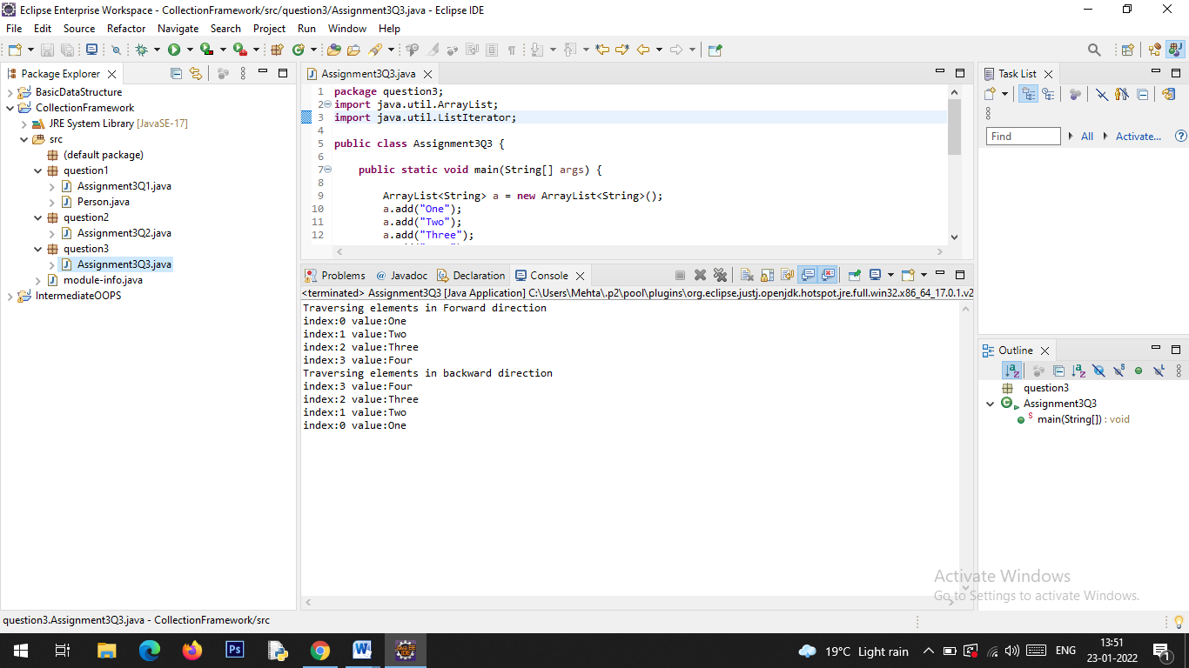

Q4. Write a program using Hashtable or HashMap where Date of birth is a key & Employee name as value. Design the class Date is such a way where the get method fails if two employees have same day & month of birth but birth year is different.

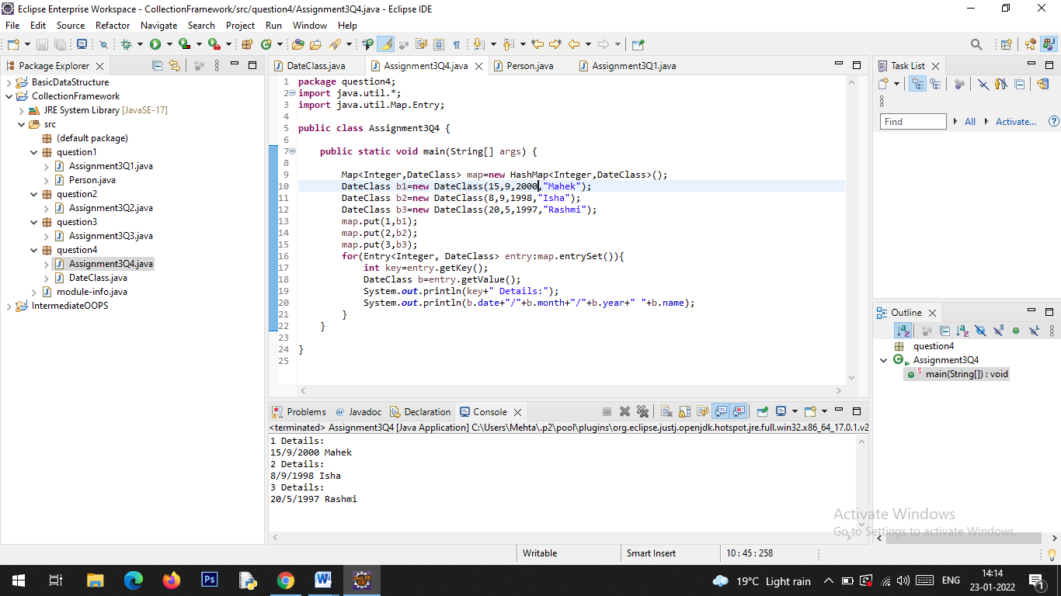

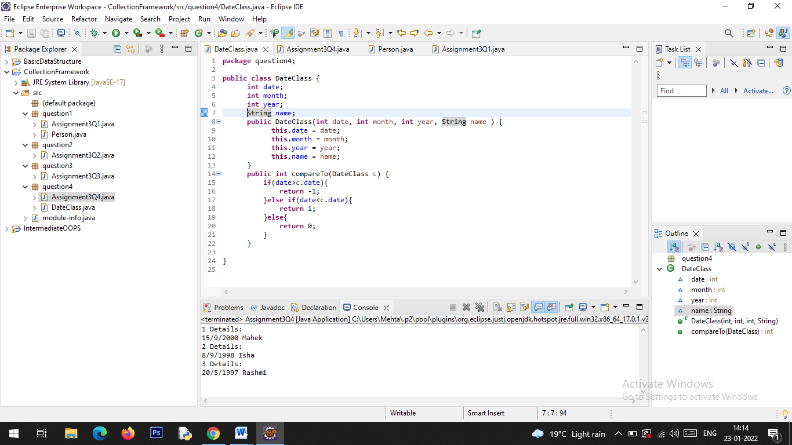

**Output:**

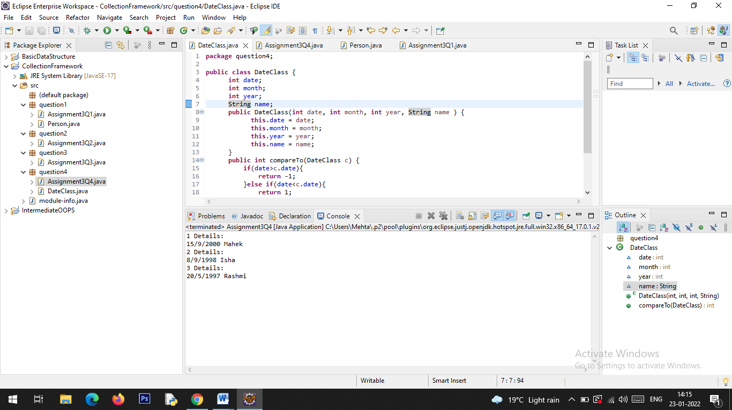

Q5. Write a user defined class say Employee that overrides equals() & hashCode() methods. Equals() always returns true & hashCode() always returns a fixed number. Make such a class as key of you Hashtable. Observe the behavior while calling put & get methods.

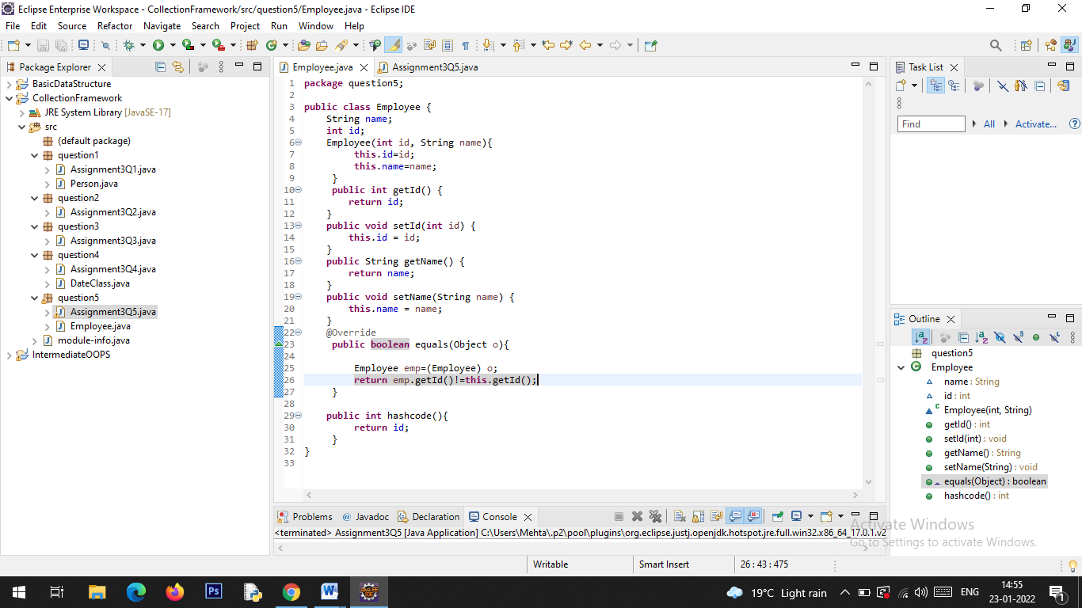

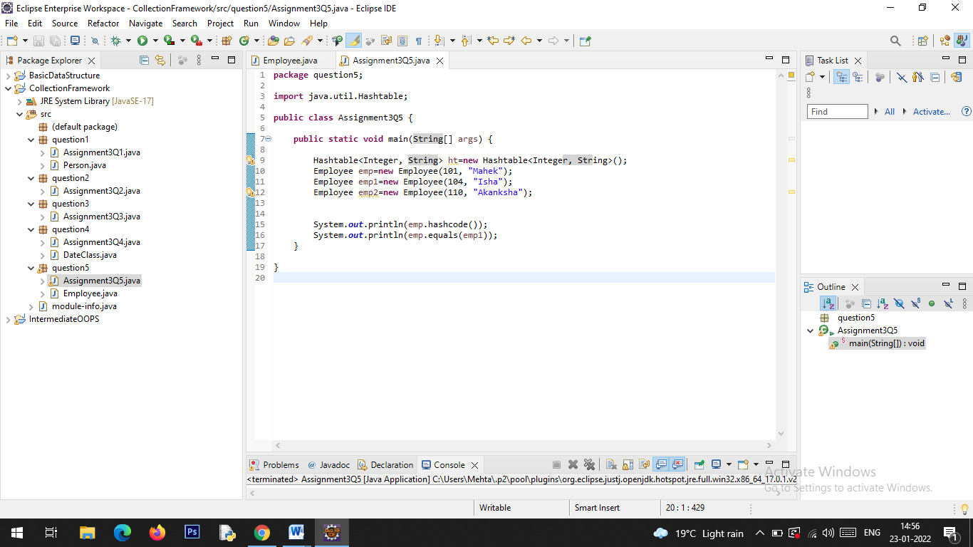

**Output:**

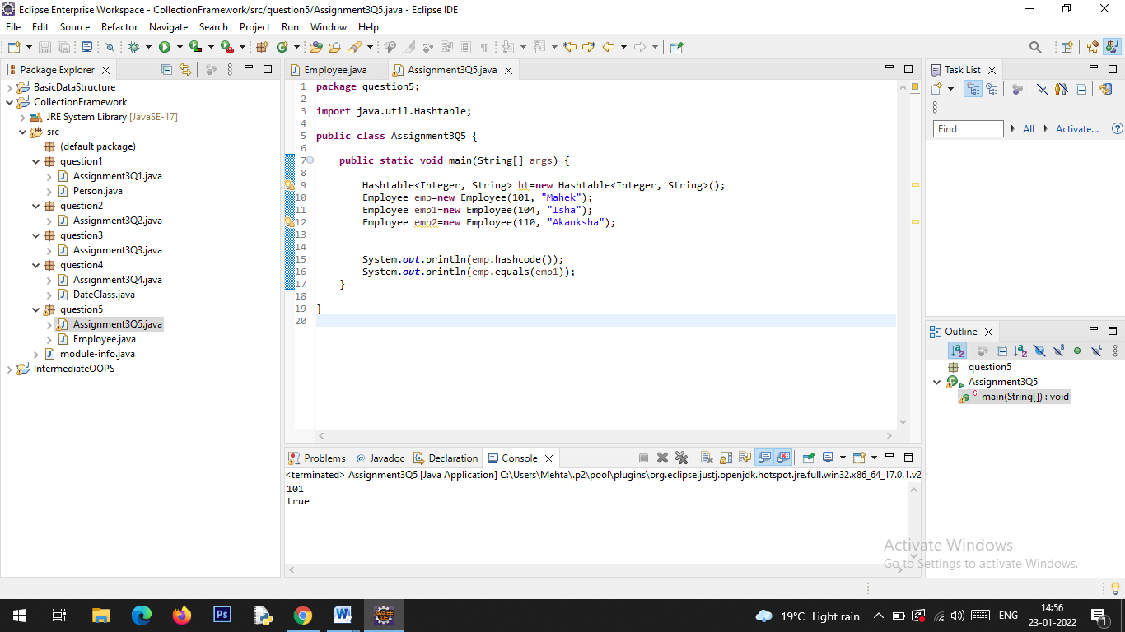

Q6. Implement the console based chatting using collections. Here are the options to be placed for to the user:

>java ChatApplication

Options:

A) Create a chatroom

B) Add the user

C) User login

D) Send a message

E) Display the messages from a specific chatroom

F) List down all users belonging to the specified chat room.

G) Logout

H) Delete an user

I) Delete the chat room.

Please enter your option:

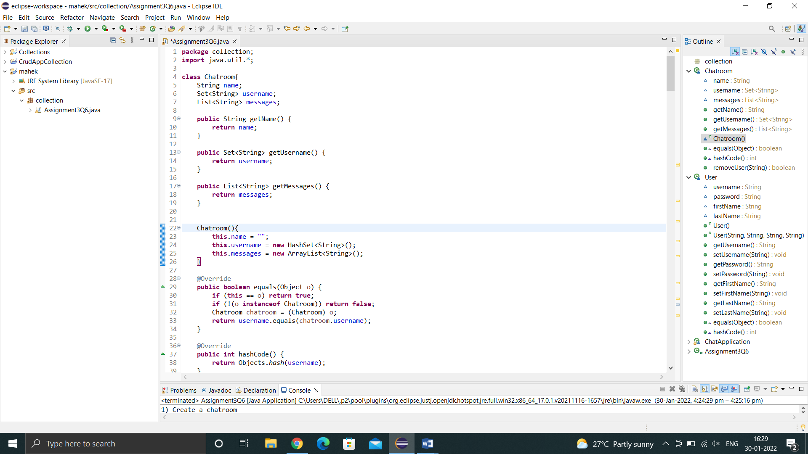

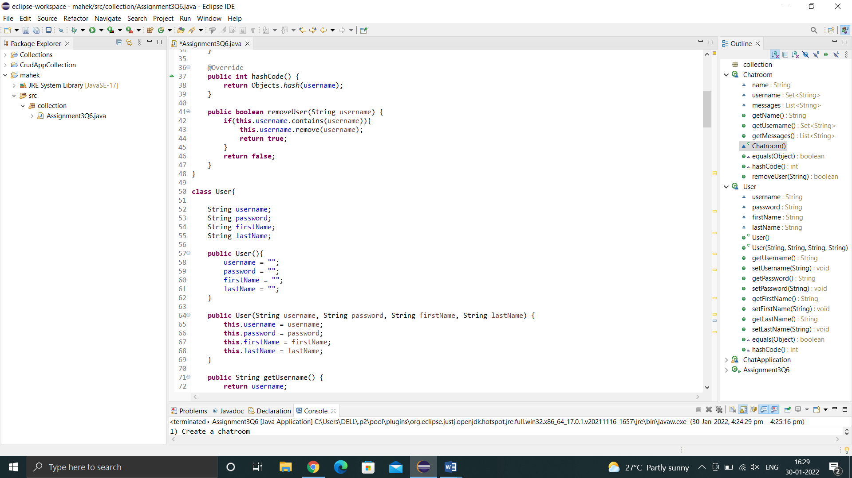

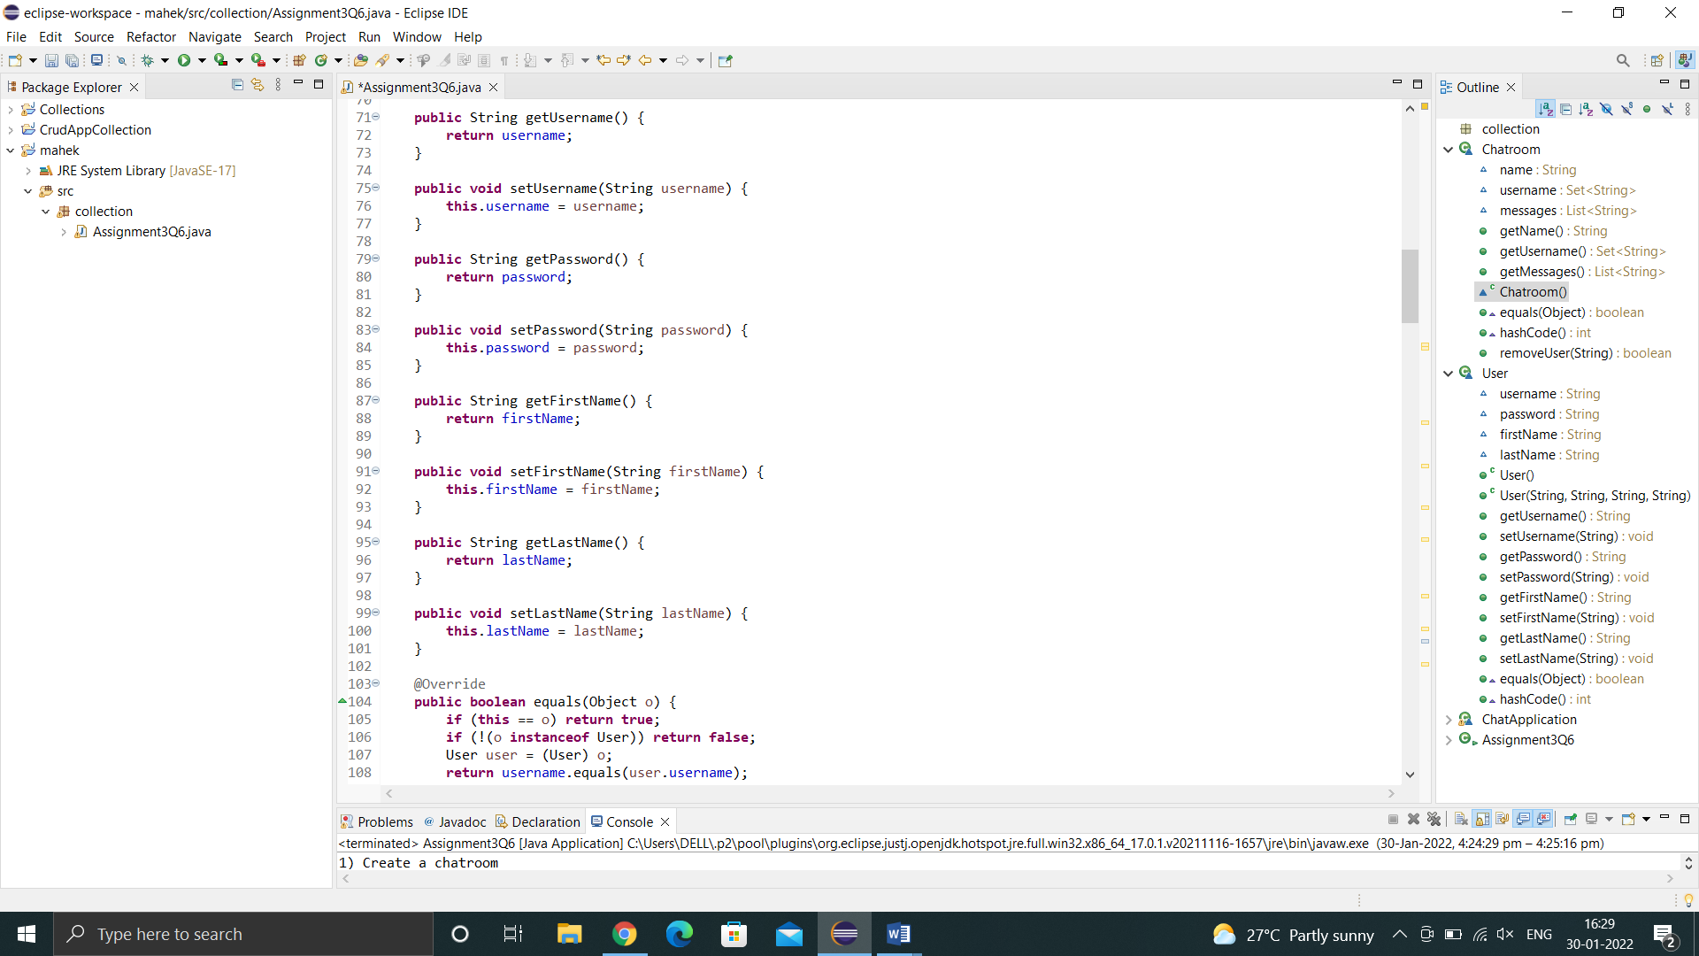

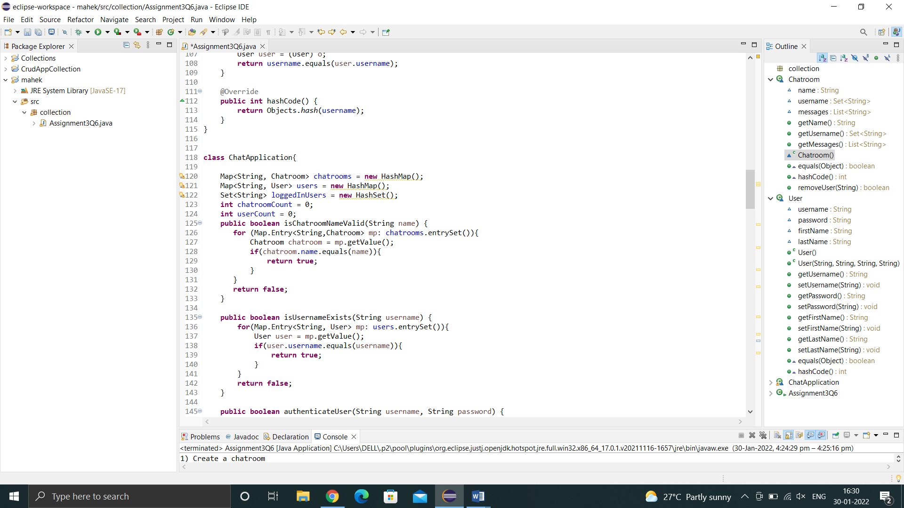

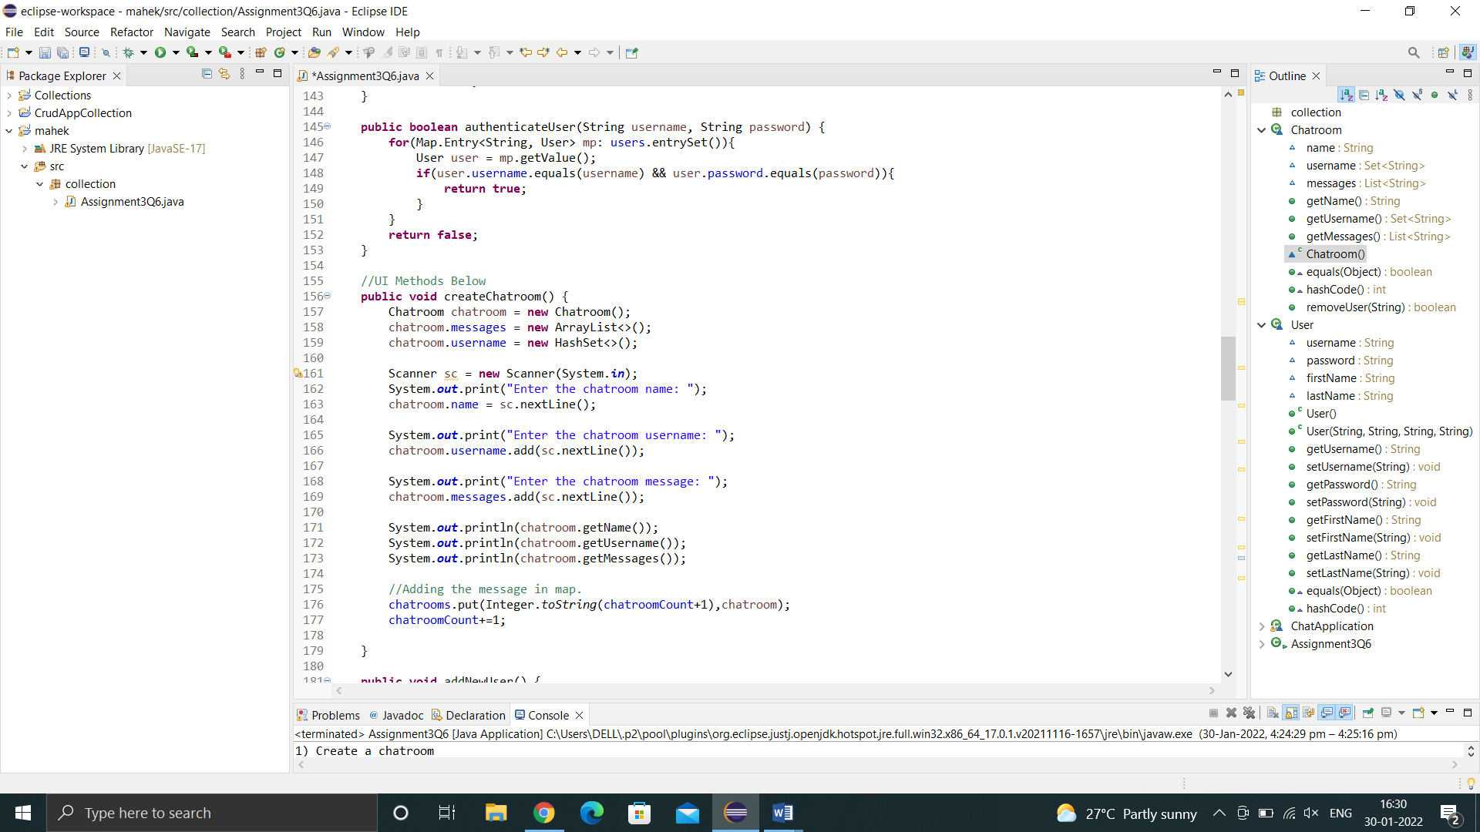

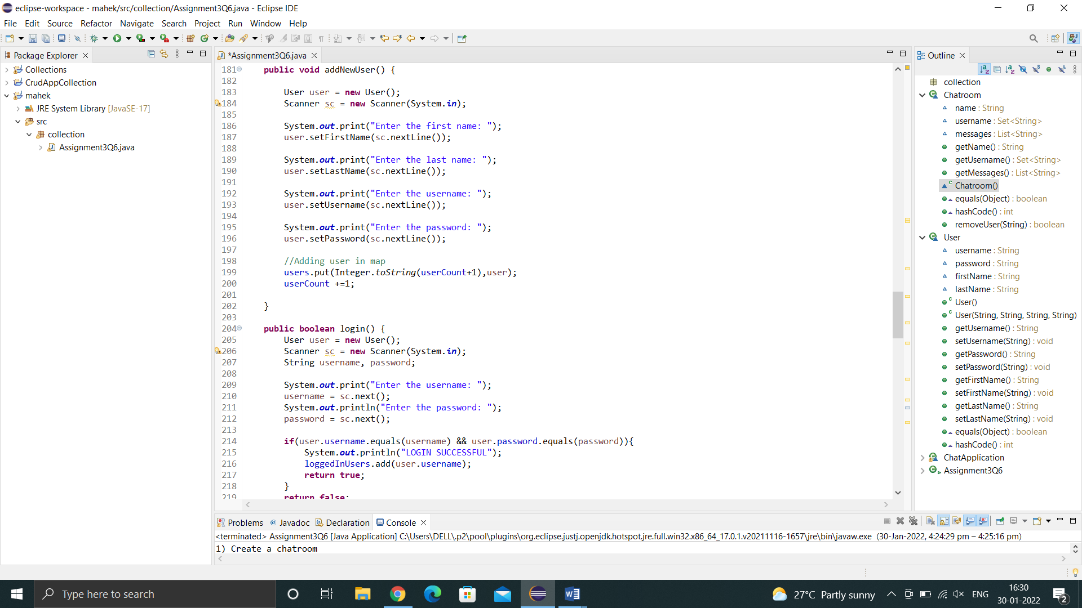

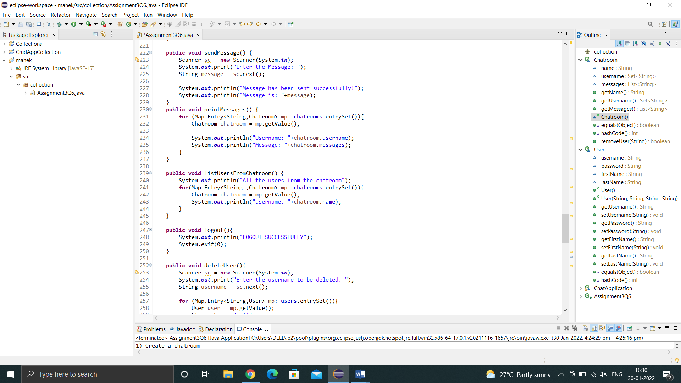

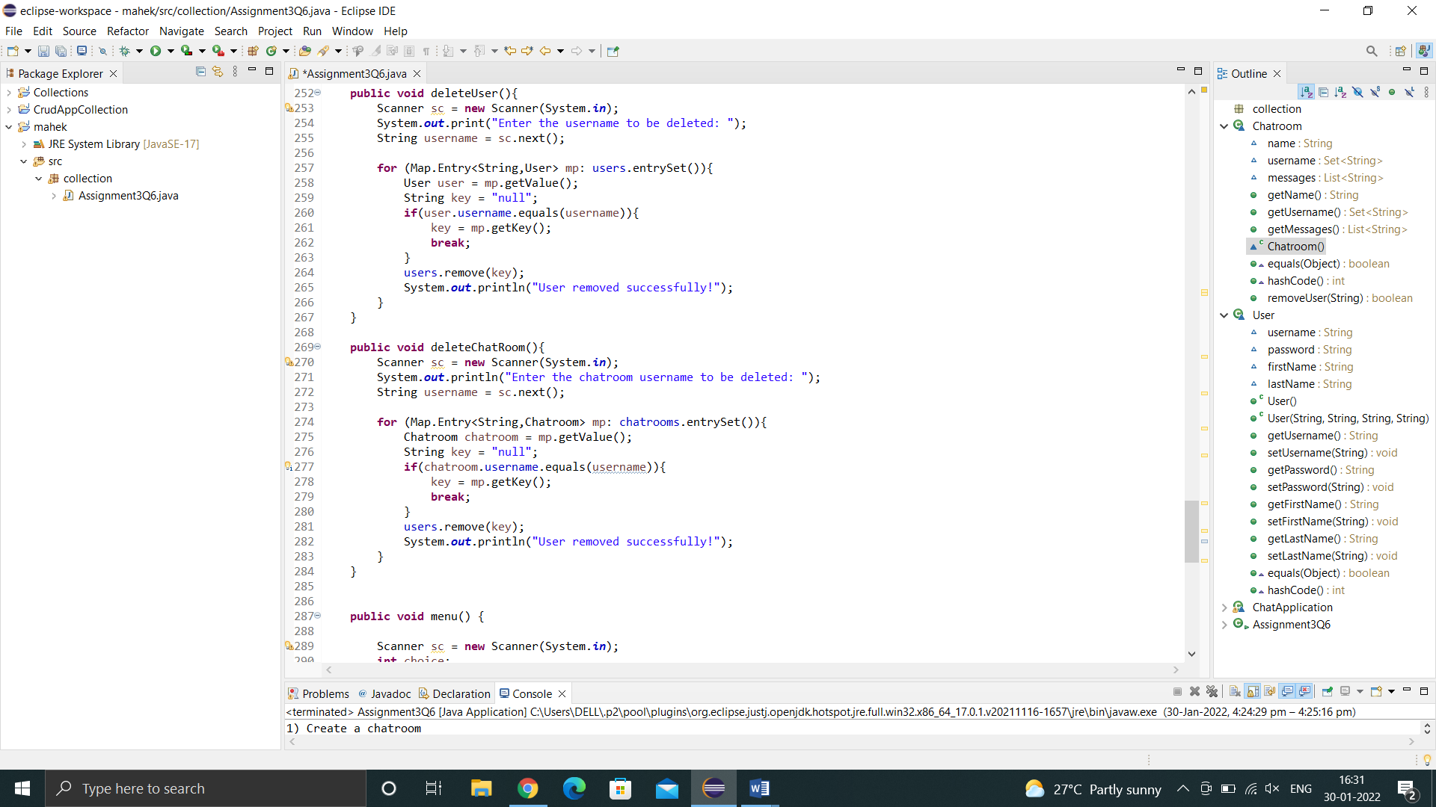

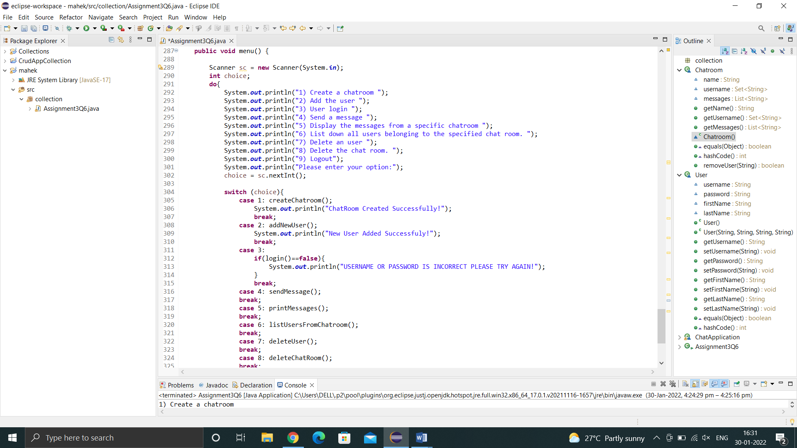

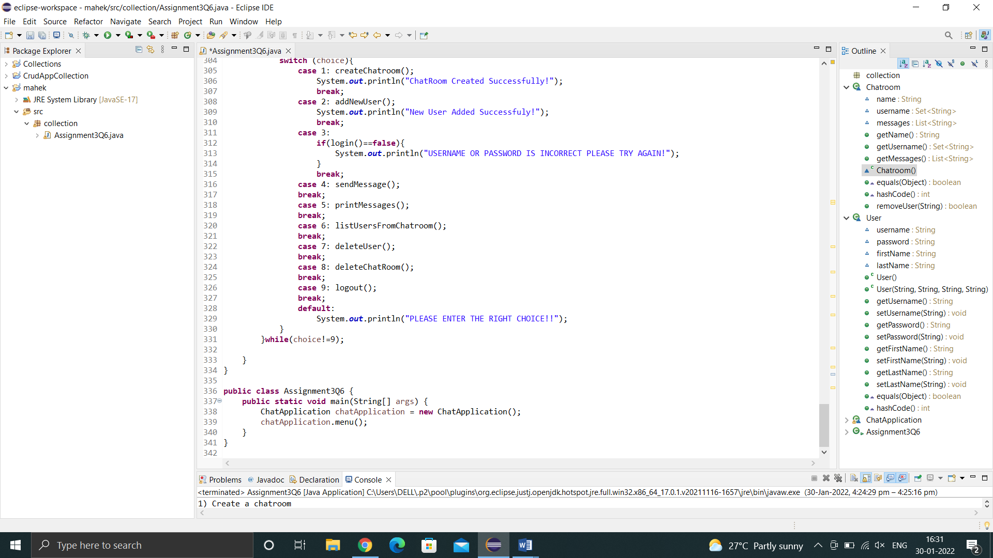

**Output:**

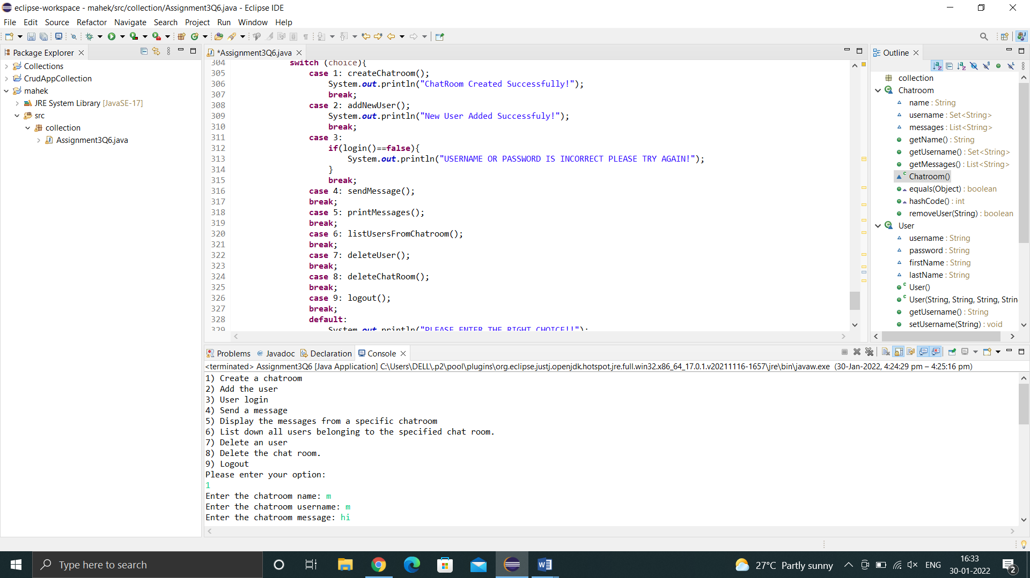

Q7. There is parking slot available in R-Mall with 3 floors; each floor has 4 sections and each section can maximum park 20 cars. You need to design one application which will maintain all car details in such way when a car owner arrives to collect his care your application should provide details including where it is located.

a. Create class Parked_CarOwner_Details which will have field’s owerName, carModel, carNO, owerMobileNo, owerAddress with setter and getter methods.

b. Create class Parked_CarOwenerList which will have method’s int add_new_car(Parked_CarOwner_Details obj), remove_car(), get_parked_car_location(token).

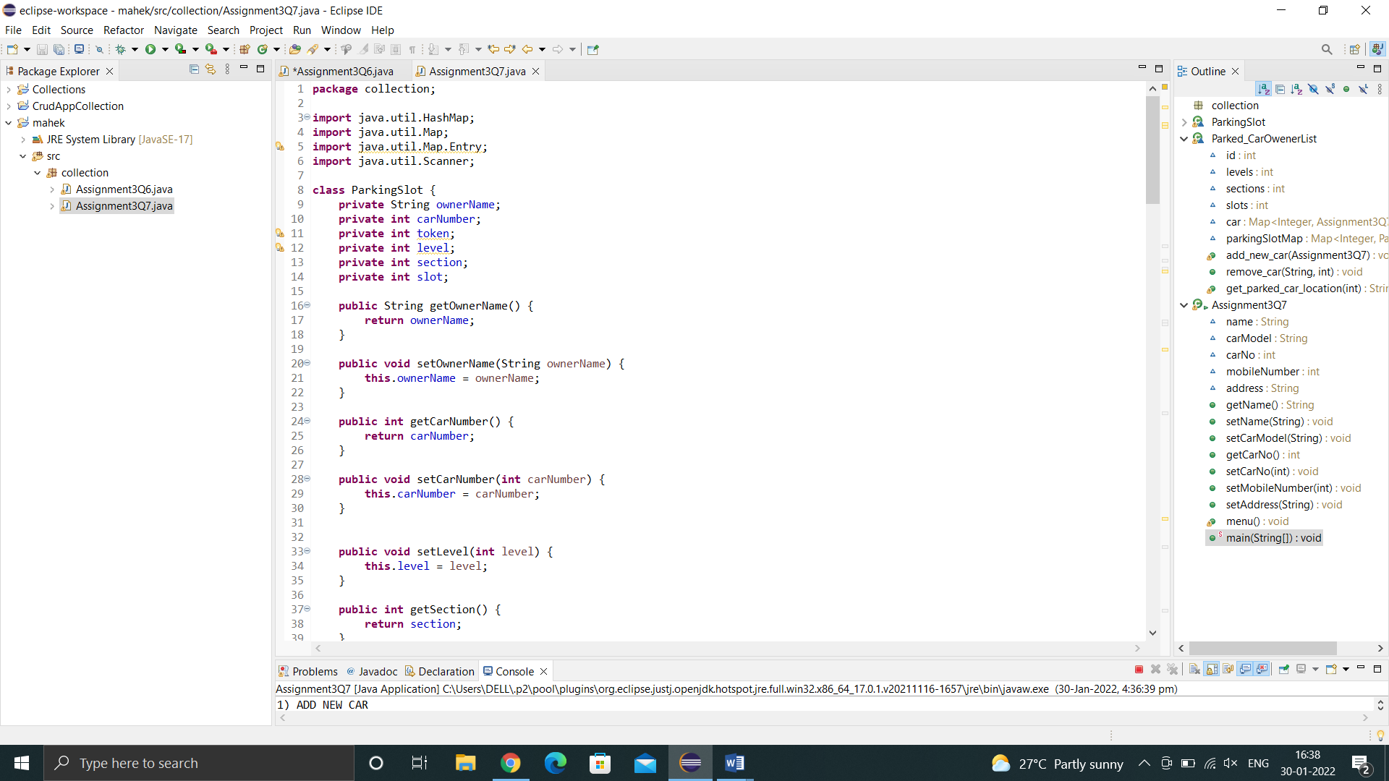

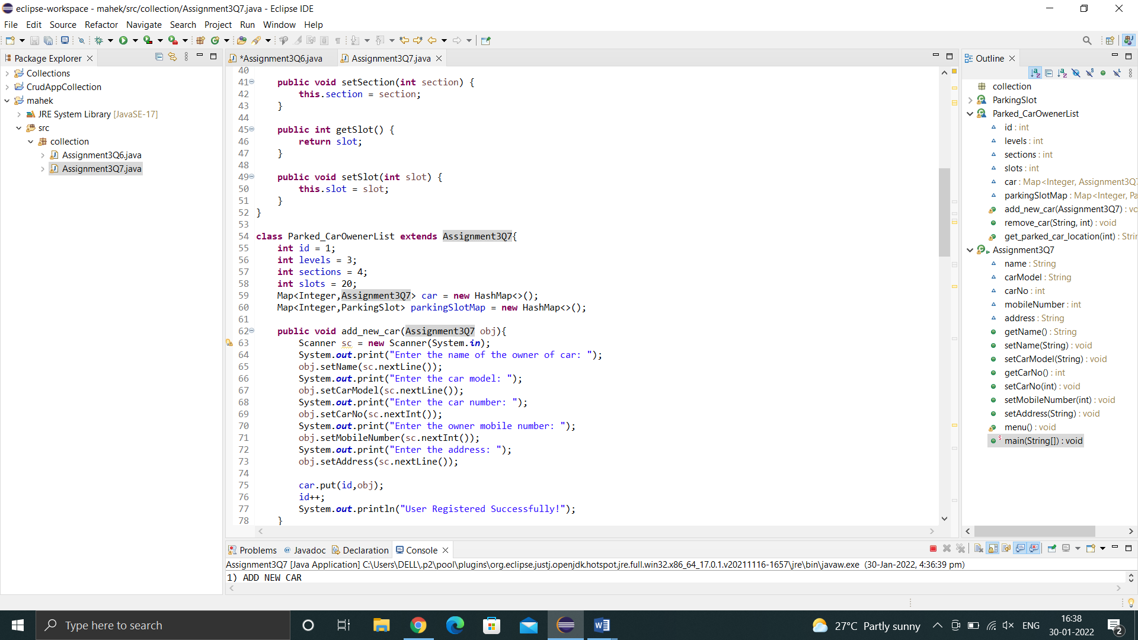

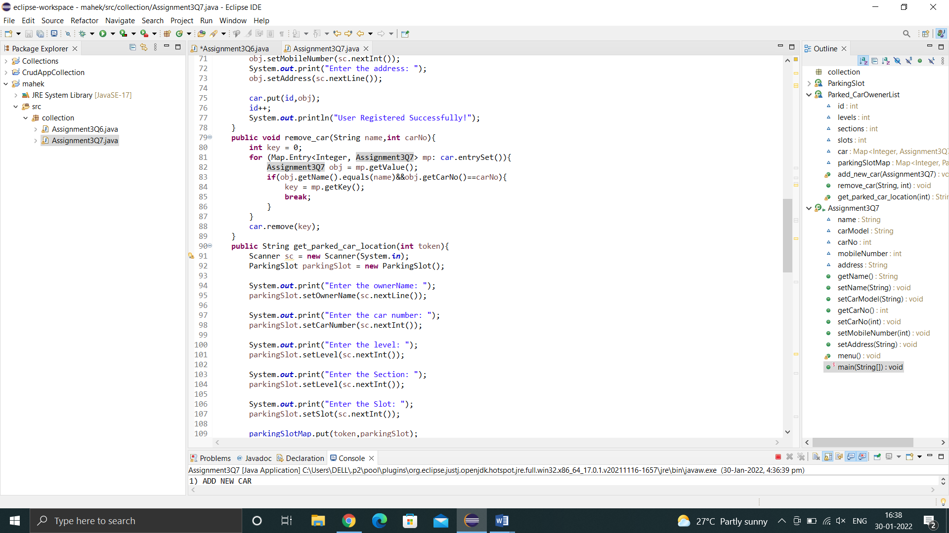

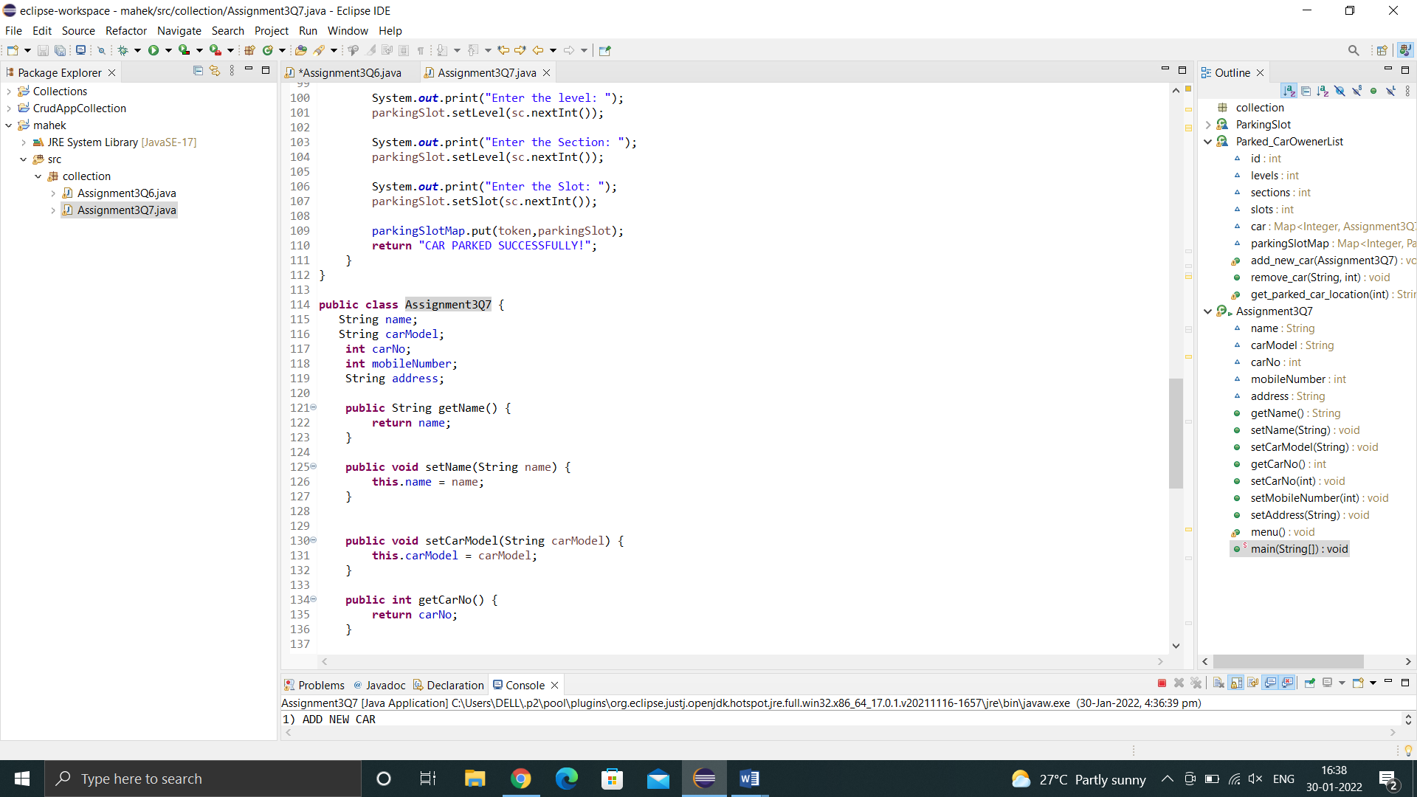

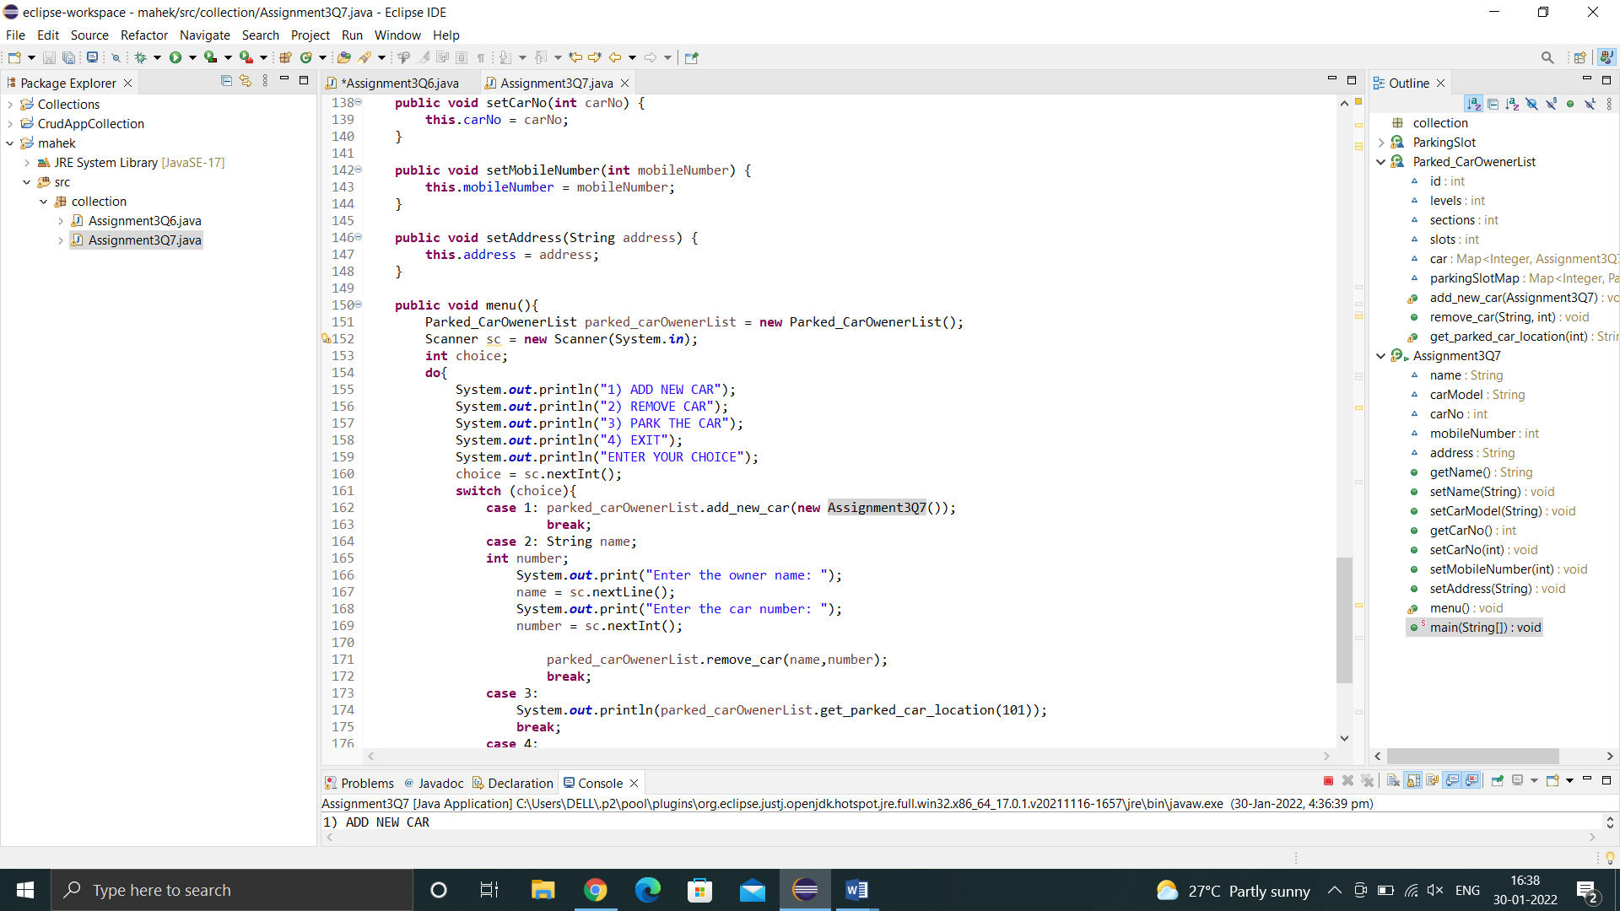

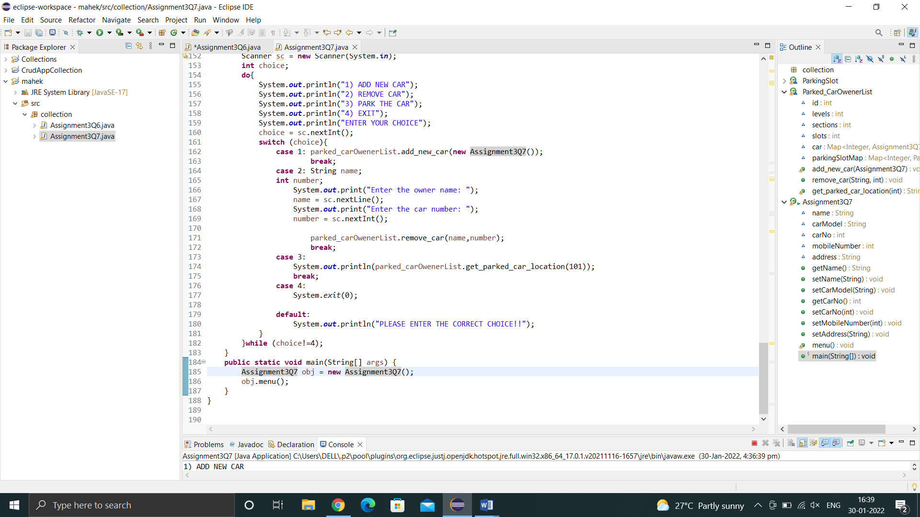

**Output:**

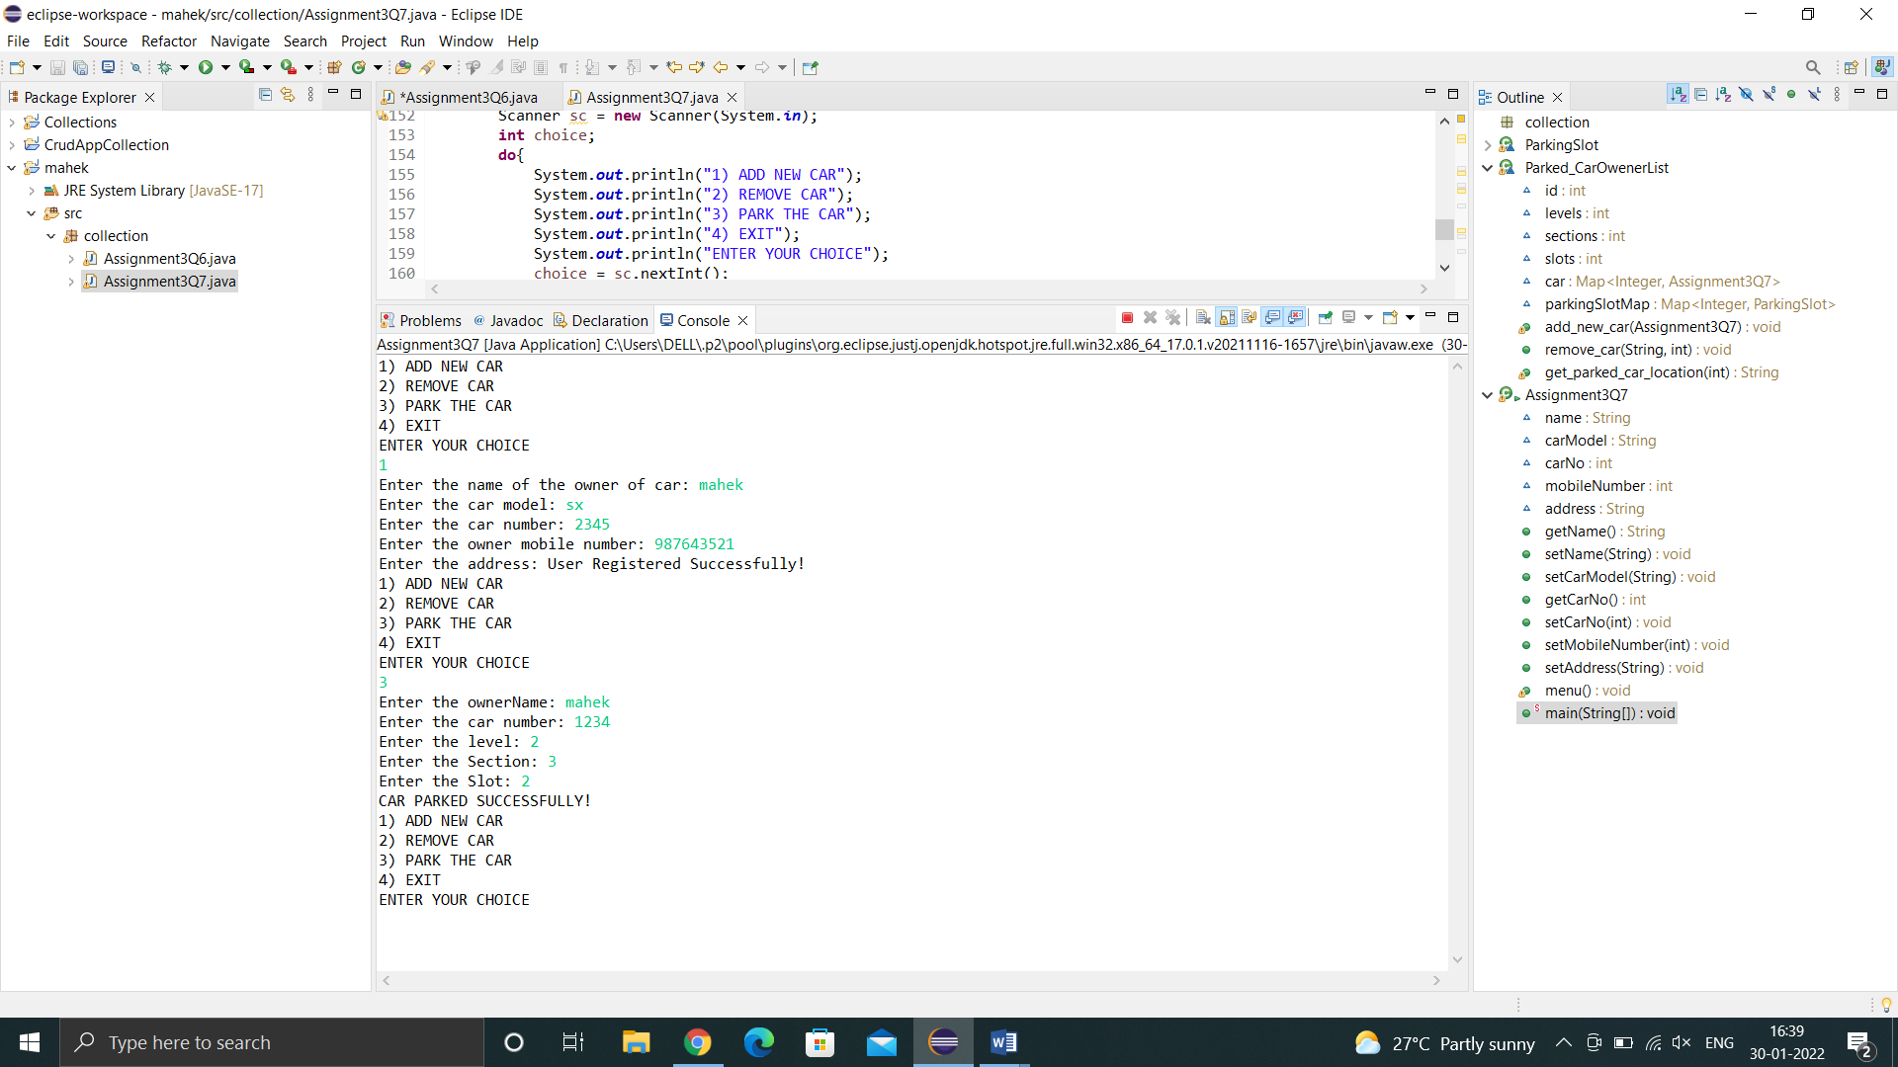

Q8.1 Test fail-fast iterators within multithreaded environment. Note example of fail fast iterator is Vector, ArrayList, HashSet etc. And fail-safe is ConcurrentHashMap, CopyOnWriteArrayList etc**.**

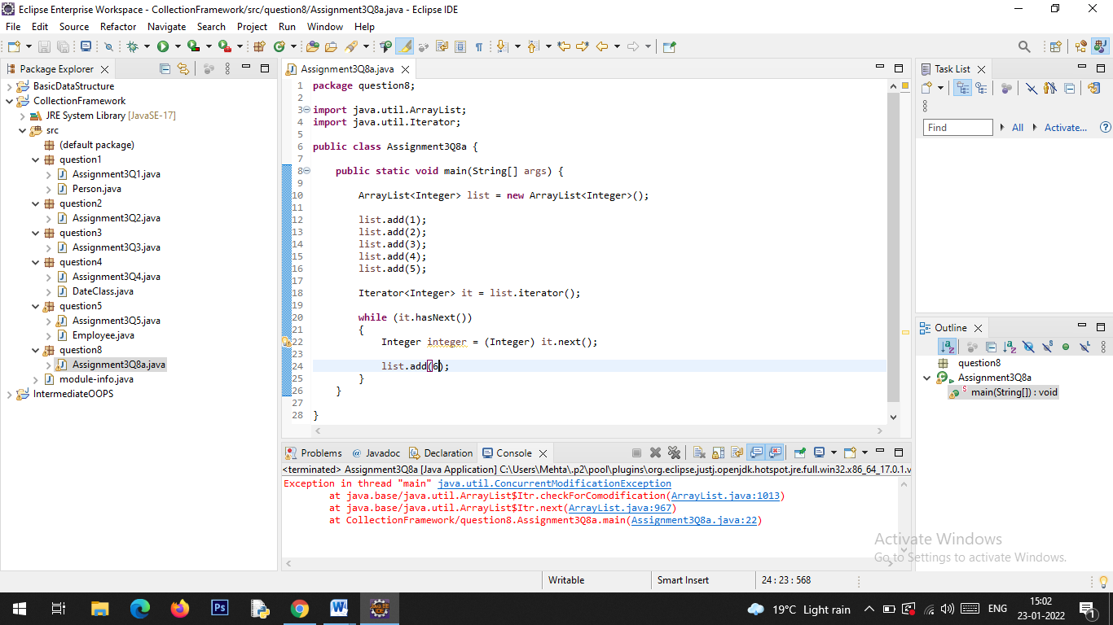

**Output:**

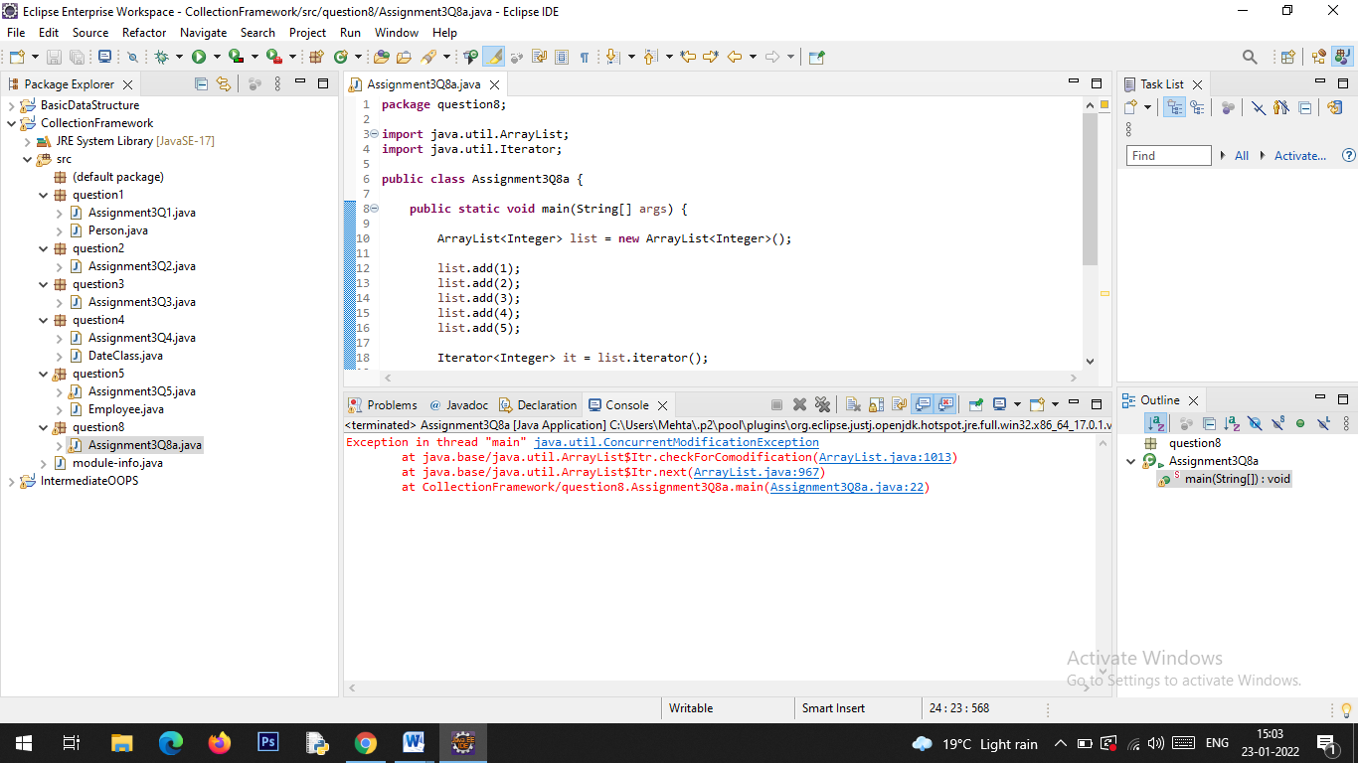

Q8.2 Test fail-safe iterators within multithreaded environment. Note example of fail fast iterator is Vector, ArrayList, HashSet etc. And fail-safe is ConcurrentHashMap, CopyOnWriteArrayList etc.

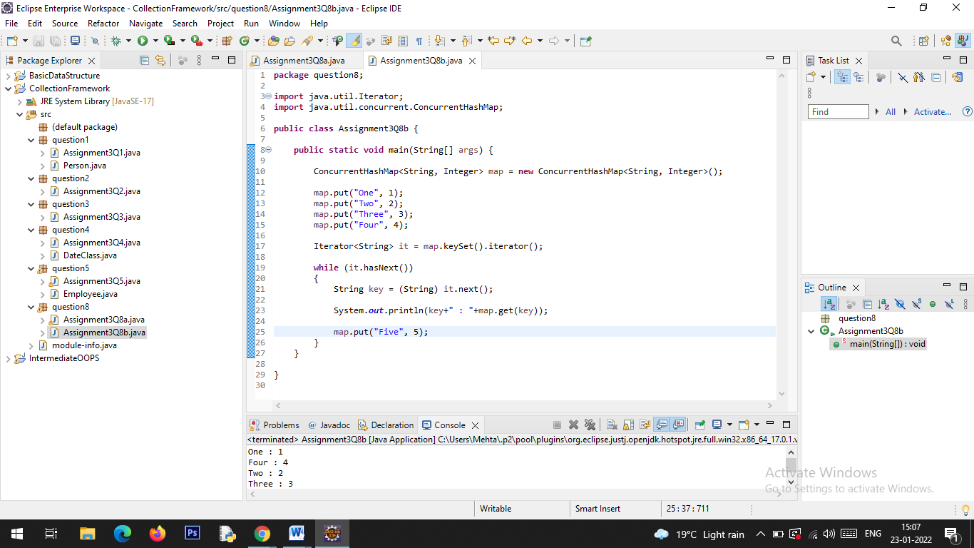

**Output:**

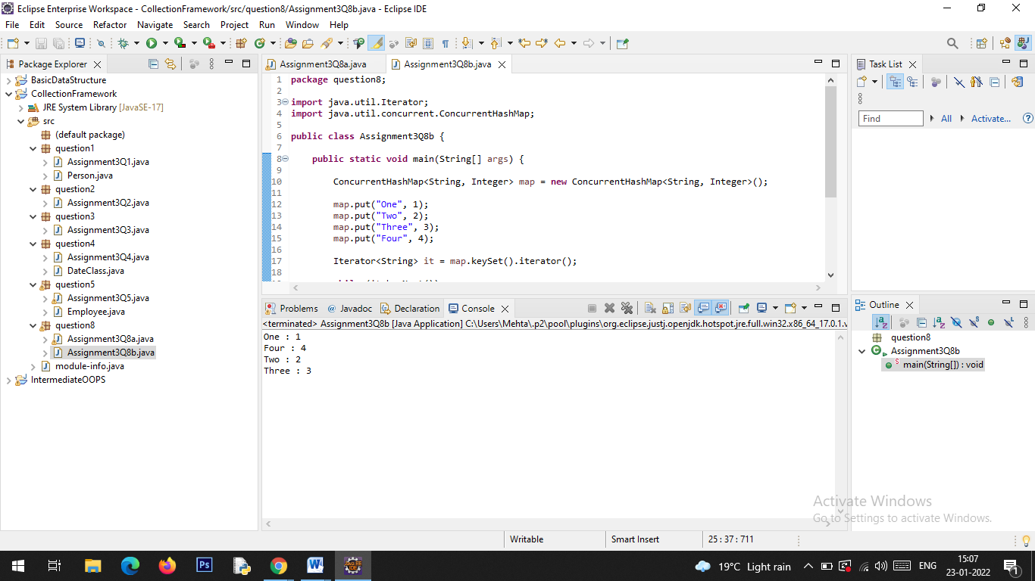

Q9. Create a Class SavingAccount with field’s acc_balance, acc_ID, accountHoldername, isSalaryAccount. Also add setter and getter methods with business method like withdraw and deposit.

a. Create class BankAccountList which will maintain SavingAccount objects. Ensure that this class should not allow duplicates as well as data should be displayed in sorted order. (as per acc_ID)

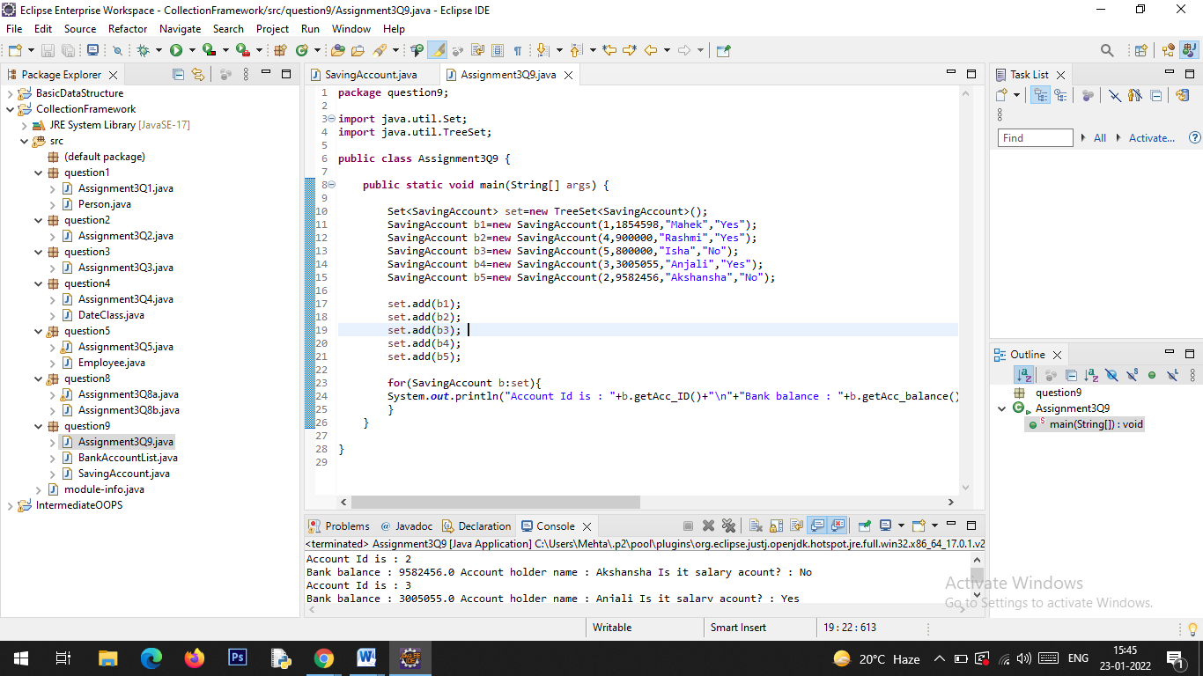

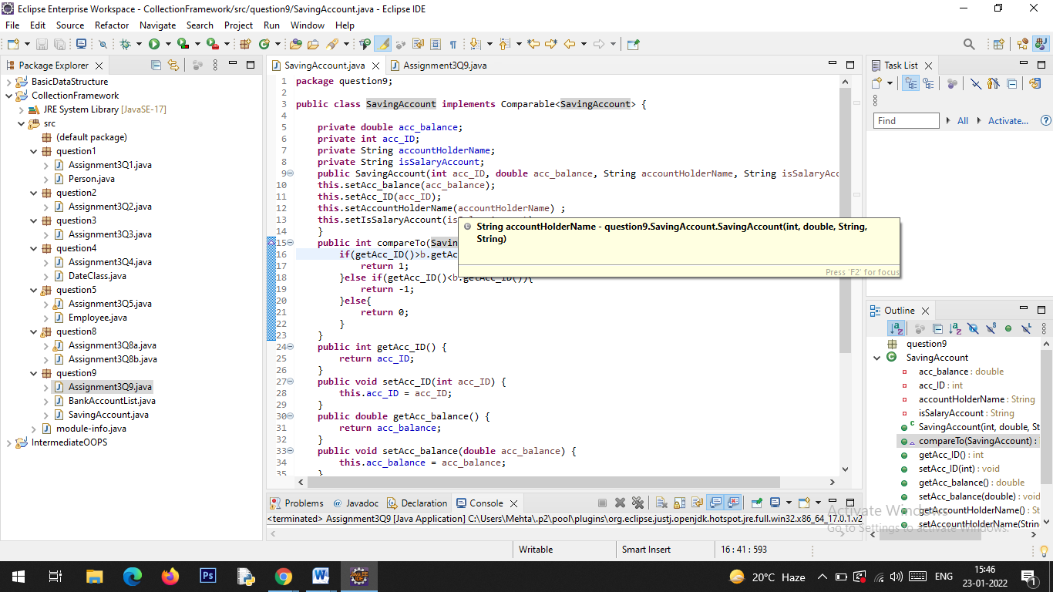

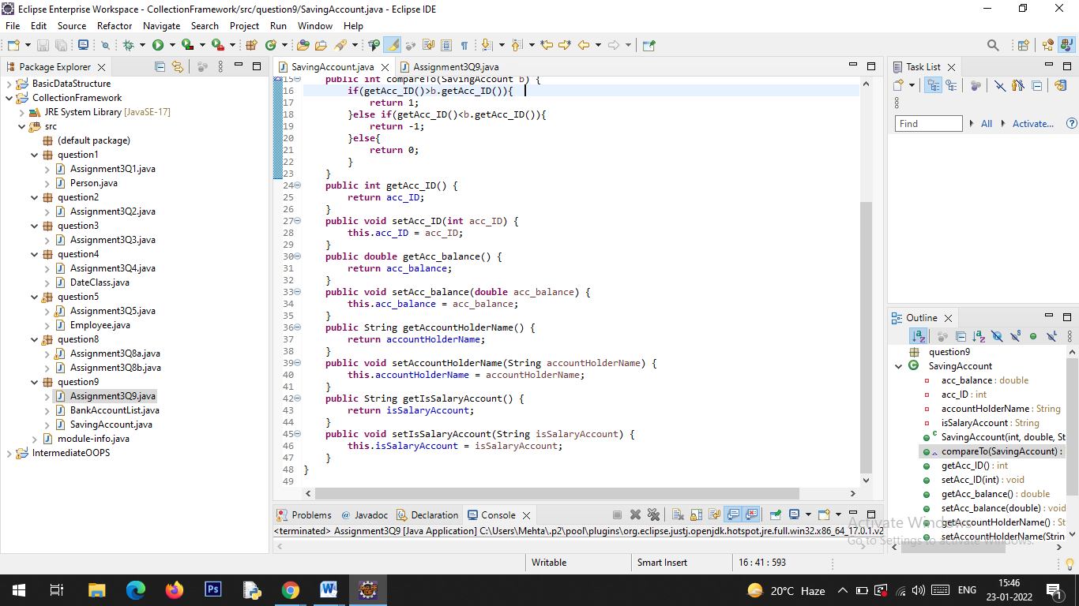

**Output:**

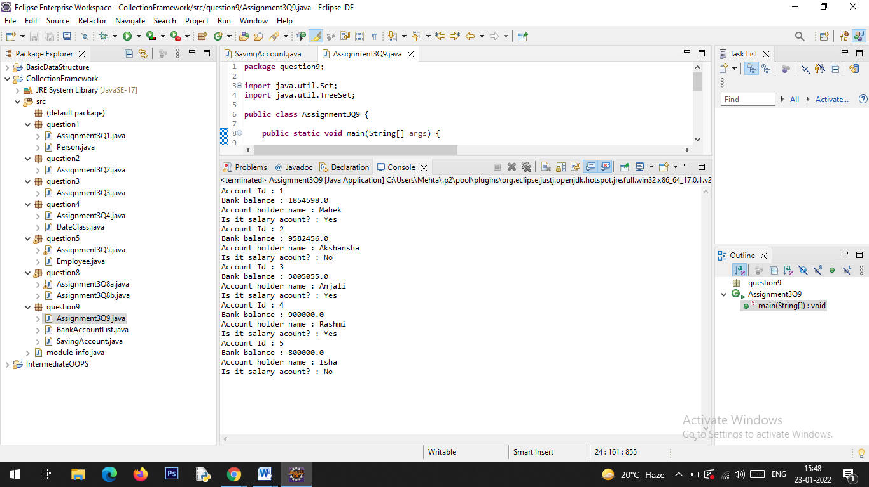

Q10. Create class Movie_Details with field’s mov_Name, lead_actor, lead_actories, and genre add setter and getter method in that class.

a. After creating this class create class Movie_DetailsList class who will maintain all the objects.

b. Movie_DetailsList class should have method add_movie(), remove_movie(), remove_AllMovies(), find_movie_By_mov_Name(), find_movie_By_Genre()

c. Movie_DetailsList should have method which will take an argument that will be use to determine on which to sort

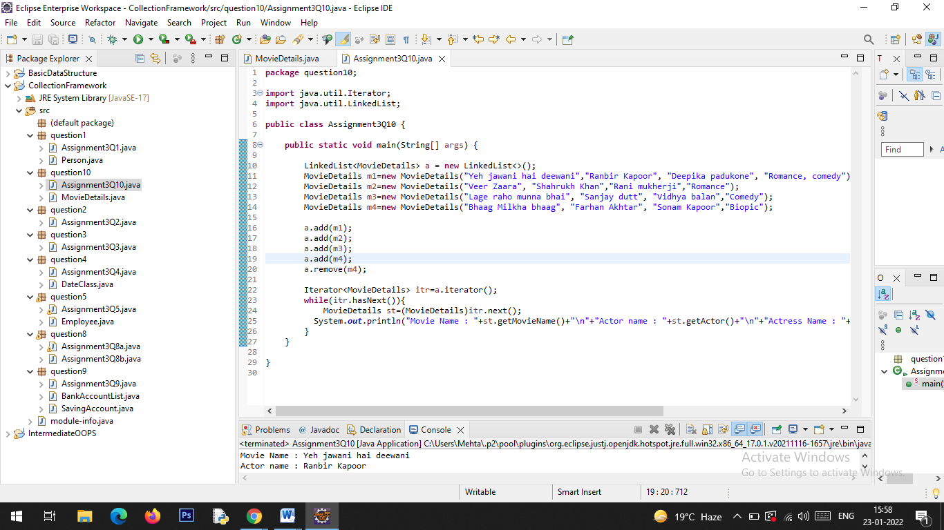

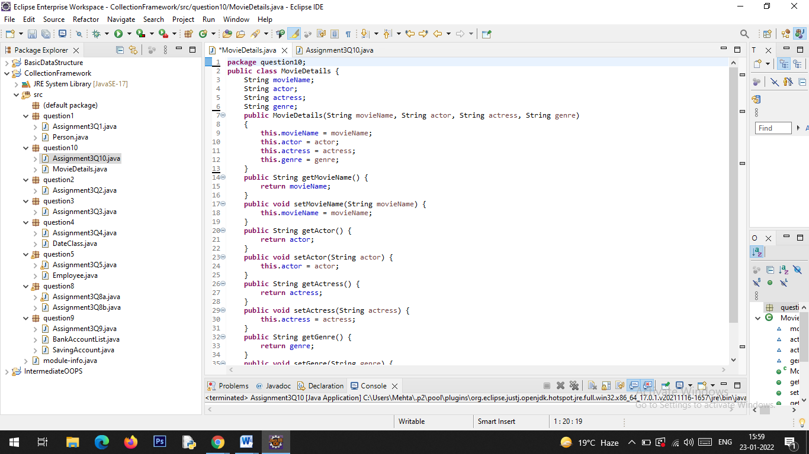

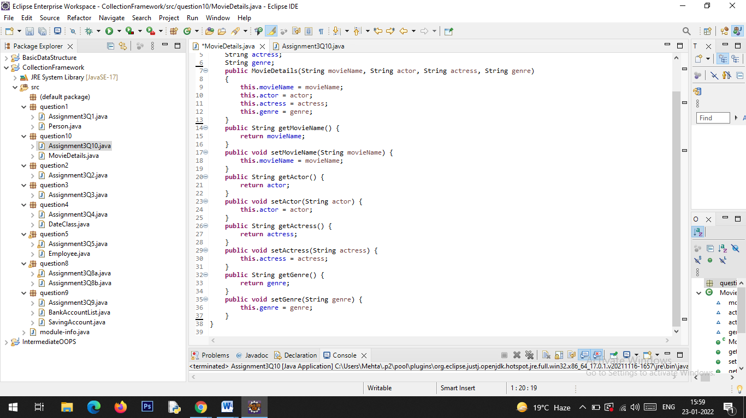

**Output:**

